Episode 322: Diffraction gratings

The diffraction grating was named by Fraunhofer in 1821, but was in use before 1800. There is a good case for describing it as the most important invention in the sciences.

Summary
Demonstration: Looking through gratings. (10 minutes)
Discussion: Deriving the grating formula. (20 minutes)
Student experiment: Measuring wavelength. (30 minutes)
Student questions: Using the grating formula. (30 minutes)
Student experiment: A CD as a grating (home experiment). (30 minutes)
Discussion: The meaning of coherence (10 minutes)

Demonstration:
Looking through gratings
Pass around some diffraction gratings or hand-held spectroscopes. Invite students to look through them at various light sources: a torch bulb, LEDs of different colours, a sodium or mercury lamp. They should see a continuous spectrum (red to violet) for a white light source, but multiple images of different colours for coloured sources.
Shine a laser through a grating (as in the Young’s slits experiment above). Explain that light rays are emerging from each slit. What condition must be met for a maximum on the screen? (All rays must be in phase with each other.)
Observe the effect of moving the screen further away (the maxima are further apart). Try a grating with a different slit spacing. (Closer slits give maxima that are further apart.)
Shine a bright white light through the grating and observe the resulting spectra.
Describe the central maximum as ‘zero order’. The next maximum on either side is then ‘first order’ (n = 1), and so on. You will probably observe two or three on each side, far fewer than with a double slit. (It’s a much more demanding condition to have many rays in phase than just two.)
It is hard to overstate the importance of the diffraction grating to the progress of the sciences. Some would claim it as the most important invention, used in investigations from the structure of matter including DNA (being used as its own ‘grating’) to the structure of the Universe (from Doppler shifted spectral lines), and the determination of the composition of everything from stars to chemical compounds, by analysis of their spectra.

Discussion:
Deriving the formula
You may need to derive (or simply present) the grating formula first derived by Young 1801:
d sin θ = n λ
where d = the grating separation (the distance between slits). NB gratings are often specified as so many lines per metre (often on ‘old’ gratings as per inch, so beware if doing quantitative work!). Separations as small as 100 nm possible, = 10 million lines per metre (equivalent to about 40,000 lines per inch).
Note that this formula gives the directions for the maximum intensities (cf the single slit formula which gives directions for the minimum intensity).
Point out that smaller wavelengths give smaller angular separations. (You should have observed that violet light is diffracted less than red light.)

TAP 322-1: A transmission grating

Student experiment:
Measuring wavelength
Students can determine the wavelength of laser light using a diffraction grating. They could discuss the relative precision of this method, compared with the two-slit arrangement.

TAP 322-2: Measuring the wavelength of laser light

Student questions:
Using the formula

Students can perform calculations relating to diffraction gratings.

TAP 322-3: Grating calculations

They can interpret some images made using gratings.

TAP 322-4: Using diffraction gratings

Student experiment:
A CD as a grating (home experiment)

Use a CD as a reflection diffraction grating. This experiment can be done at home.

TAP 322-5: Using a CD as a reflection grating

Discussion:
The meaning of coherence
Now that your students have had practical experience of observing maxima and minima, further discussion of the necessary conditions should make sense. For superposition effects to be observable, the conditions must persist for a time long enough for them to be observed and extend far enough in space for a reasonably-sized pattern. It is easier for this to be the case if the waves have a well-defined frequency or wavelength (they must be monochromatic).
Ordinary light sources emit light in ‘overlapping bursts’, are not usually monochromatic (so the number of wavelengths in a given path can vary) and no source is a true point (so a range of path lengths is inevitably involved).
Laser light is particularly useful for showing interference effects because it is intense, highly monochromatic, and emitted in long wave trains and so maintains a constant phase relationship over large distances. We say that the waves arriving along two or more paths are said to be coherent.

TAP 322-6: Coherence

TAP 322- 1: A transmission grating

Many slits produce bright, sharp beams.

Practical advice
This diagram is provided here for use in the classroom.

External reference
This activity is taken from Advancing Physics chapter 6, 65O

TAP 322- 2: Measuring the wavelength of laser light

An experiment using the relationship nλ = d sin θ
The demonstration shows how a grating produces a series of maxima of intensity. The angles at which the maxima are found let you measure the wavelength of the laser light.

You will need
- laser
- lens, –20 D
- lens, +4 D
- metre rule
- lens holders
- support for slits
- set of coarse gratings
- projector screen or light-coloured wall

   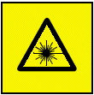   | Safety  Provided the laser is class 2 (less than 1 mW), the warning ‘Do not stare down the beam' is sufficient.

What to do

The idea is to shine the laser light through a grating – an array of many slits, not just two. To get the laser beam to go through many slits it has to be broadened. That is what the lenses in the diagram are for.
1. Shine the diverged laser light through one of the gratings and use the converging lens to focus the pattern on the screen.
2. Change the grating for one with a smaller slit spacing. What do you observe?
3. Change the grating for one with a greater slit spacing. What do you observe?
4. Choose a grating which gives several bright patches on the screen. Choose one patch and find n by counting out from the centre (the centre counts as zero). Measure how far the bright patch is from the centre, and how far the screen is from the grating. Calculate the angle θ.
5. Use the formula nλ = d sin θ to find the wavelength of the laser light.

You have
1. Seen the maxima separate as the slits are brought closer together.
2. Practised using the grating formula.

Practical advice
This is a simple, effective demonstration. It should focus on the effect of grating spacing, not on the number of slits. It is worth drawing attention to the fact that grating spectra are bright and sharp, compared with the two-slit pattern.

      | Safety  Provided the laser is class 2 (less than 1 mW), the warning ‘Do not stare down the beam' is sufficient. Take care to avoid reflections.

Social and human context
Joseph Fraunhofer (1787–1826) was the first to use a grating to produce a spectrum from white light. The Fraunhofer dark lines in the spectrum of the Sun, which reveal chemical elements present in the Sun, are named after him. He was a poor boy with little education who found a job in an optical works housed in a disused abbey near Munich. It made high-quality glass, and by his twenties Fraunhofer was put in charge of the optical department. It was in the pursuit of careful measurement of optical properties of glass that he used gratings, to obtain monochromatic light.

External reference
This activity is taken from Advancing Physics chapter 6, 240E

Park D 1997 The fire within the eye (Princeton University Press)

TAP 322- 3: Grating calculations

These questions give you practice in using the grating formula n λ = d sin θn.

A grating is labelled '500 lines per mm'.
1. Calculate the spacing of the slits in the grating.

2. Monochromatic light is aimed straight at the grating and is found to give a first-order maximum at 15º. Calculate the wavelength of the light source.

3. Calculate the position of the first-order maximum when red light of wavelength 730 nm is shone directly at the grating.

4. The longest visible wavelength is that of red light with λ = 750 nm. The shortest visible wavelength is violet where λ = 400nm. Use this information to calculate the width of the angle into which the first-order spectrum is spread out when white light is shone onto the grating.

A grating is illuminated with a parallel beam of light of wavelength 550 nm. The first-order maximum is in a direction making an angle of 20º with the straight-through direction.

5. Calculate the spacing of the grating slits.

6. What would be the angle of the first-order maximum if a grating of slit spacing of
2.5 × 10–6 m were used with the same light source?

7. Calculate the wavelength of light that would give a second-order maximum at θ = 32º with a grating of slit spacing 2.5 × 10–6 m.

Hints
1. What must the gap be between the centre of each line in order to fit 500 lines into 1 mm? Remember to express your answer in metres.
2. This is about the first-order minimum so use the formula nλ = d sin θ  with n = 1.
3. Rearrange the formula nλ = d sin θ  to make sin θ the subject. Remember to take the arcsin (or sin^{–1}) to give an answer in degrees.
4. Use the same method as question 3 to obtain the position of first-order maxima for red and violet light. The dispersion is simply the angle of maximum of red light minus the angle of maximum of violet light.

Practical advice
A set of simple practice questions, to build confidence.

Social and human context
These questions introduce the idea of interference gratings used to obtain spectra. This has been extremely important in the development of modern astronomy.

Answers and worked solutions
1. Number of slits per mm = 500. Therefore, slit spacing = 1 / 500 = 0.002 mm = 2 x 10^{–6} m.
2.
Therefore
3.
Therefore
from which θ = 21°.
4.
For red light:
angle θ_{r} =  22°.
For violet light:
sin θ_{v} = λ / d = 4.0 x 10⁻⁷ m / 2 x 10⁻⁶ m = 0.20
angle θ_{v} = 12°. The difference in angle is 10°.
5.
6.
Thus
7.
Thus

External reference
This activity is taken from Advancing Physics chapter 6, 200S

TAP 322- 4: Using diffraction gratings

Instructions
The photograph shows a two-colour light-emitting diode (LED) viewed through a diffraction grating. The grating has 300 lines per millimetre and is placed over the camera lens that is 400 mm from the LED. The scale shown is in centimetres.

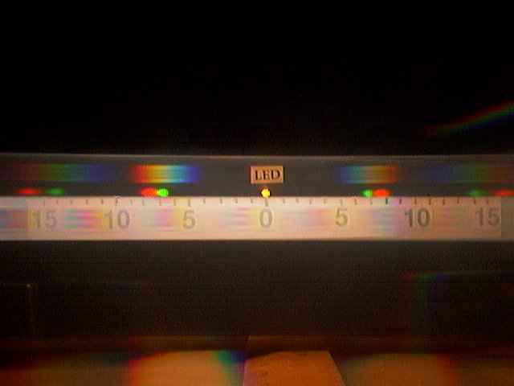

1. How can you tell that the LED is giving out two distinct colours?

2. The grating has 300 lines per millimetre. What is the spacing between the lines?

3. Look at the first-order green image, and work out the angle at which the green light is being diffracted by the grating.

4. Calculate the wavelength of the green light

5. Repeat the calculations for the first-order red image of the LED.

6. Looking at the second-order images, make further measurements to confirm your wavelength calculations.

7. How many further orders could be created using this grating?

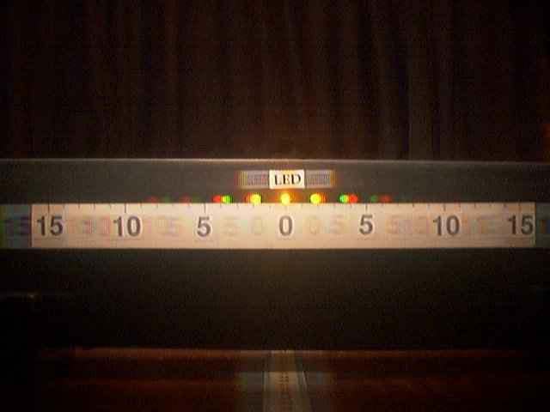

8. This photograph uses a different grating but the same LED as before. Calculate the spacing between the lines in this grating and the number of lines per millimetre on the grating.

Look carefully at the next image. It is street scene taken through a diffraction grating. There are three major light sources A, B, C. Two of these are street lights; the third is a domestic security floodlight.

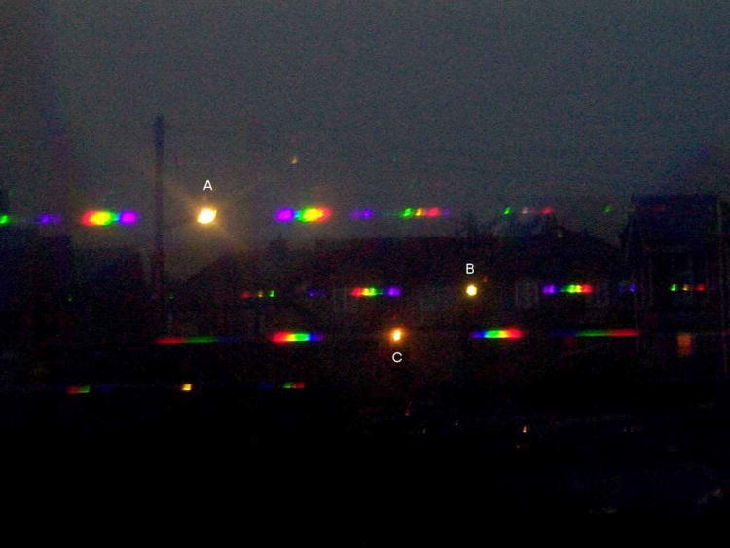

9. By looking at the spectra produced by the three sources write down the two sources that are similar. What is the difference in the spectra produced by the two types of light?

The next view of the street light shows the detail of the spectrum more clearly.

10. How many distinct colours are present in the spectrum from the street light?

11. Other street lights produce a more yellow light from 'sodium vapour lamps' which consists of only one colour of light. How would such a street light appear if viewed through a diffraction grating?
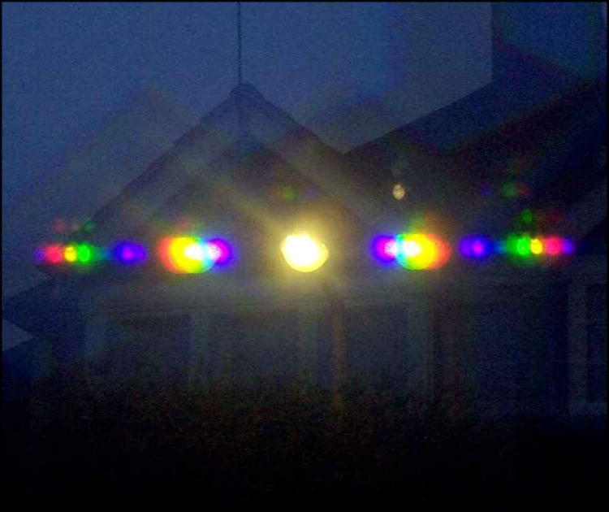

Hints
3. It may be helpful to draw a triangle showing the positions of the LED, camera and image. The angle required will be the angle subtended at the camera by the LED and its image.
4. The grating equation nλ = d sinθ  should be used here.
6. Remember that here n = 2.
7. The maximum value that sin θ  can take is 1.
8. Use the clearer second-order image to calculate d, using nλ = d sin θ . Remember this is the spacing between adjacent slits.
9. The second-order spectrum produces clearer separation of the colours.

Practical advice
This gives good practice at using the equation n λ = d sin θ.

Alternative approaches
It is a good idea, if possible, to provide students with cheap diffraction gratings to take home and use to look at a variety of sources of light.

Answers and worked solutions
1. There are two distinct coloured images of the LED in the first-order spectrum.
2. 3.3 × 10–6 m.
3. The first order green image is at about 68 mm.
tan θ = 68 mm / 400 mm
θ = 9.5º
4. λ = d sin θ
λ = 3.3 × 10–6 m sin 9.5°
λ = 550nm
5. The first order red image is at 75 mm
tan θ = 75mm / 400 mm
θ = 10.8°
λ = d sin θ
λ = 3.3 × 10–6 m sin 10.8°
λ = 620nm
6. The second order green image is at 140 mm
tan θ = 140 mm / 400 mm
θ = 19.3°
2λ = d sin θ
2λ = 3.3 × 10–6 m sin 19.3°
λ = 545 nm
The second order red image is at 152 mm.
tan θ = 160 mm / 400 mm
θ = 21.8°
2λ = d sin θ
2λ = 3.3 × 10–6 m sin 21.8°
λ = 316 nm
7. Orders are theoretically possible for angles up to 90° for sin θ < 1
so nλ / d< 1 and hence n < d/ λ:
For red light n < 3.3 × 10–6 m / 620 × 10–9 m = 5.4 so 5 orders for red light.
For green light n < 3.3 × 10–6 m / 540 × 10–9 m = 6.1 so 6 orders for green light.
8. Second order red image is at 42 mm.
tan θ = 42 mm / 400 mm
θ = 6.0°
2λ = d sin θ
d= 2λ /sin θ
d= 2 × 620 × 10–9 m /sin 6.0°
d= 1.2 × 10–5 m
= 83 lines / mm
9. A and B. The street light produces only a few specific colours of light whereas the security floodlight produces the whole range of colours in the spectrum.
10. Four colours are present: violet, green, yellow, red.
11. There would be only one band at a specific yellow colour for each order of spectrum produced.

External reference
This activity is taken from Advancing Physics chapter 6, 210S

TAP 322- 5: Using a CD as a reflection grating

An experiment for home or laboratory

The combination of the silvering and the regular grooves on a compact disc make them very effective reflection gratings. Polychromatic light is seen to reflect in rainbow colours; monochromatic light cannot be split and so remains as one colour. This experiment gives you a quick and effective method of establishing whether a light source is polychromatic or not.

You will need
- digital audio CD or CD-ROM
- light sources, selected from the following or individually chosen: daylight bulb, incandescent bulb, sodium vapour lamp, street lamps, light-emitting diode

The task
Everyone who has used a CD will have seen the rainbow patterns they create. This experiment attempts to use this effect to gather information about light sources used in everyday life. It can be performed in the laboratory, but it is very simple to look at the reflected light from a CD using light sources around your home or outside.
1. Observe the reflection of a 'white' light bulb in the CD.
2. Draw what you see, paying close attention to the intensity and position of the colours. Note the angle at which you held the CD.
3. Keeping the geometry of the set-up as similar as possible, look at other light sources. Are they polychromatic or monochromatic?
4. Try these: sodium street lights, a candle, a 'daylight' light bulb, a coloured light bulb, light shining through a coloured transparent layer such as dyed cellophane. Can you distinguish between, say, monochromatic yellow light and visual yellow – that is, light that looks yellow but is in fact a mixture of red and green?

Two things to look out for
1. CDs can make useful reflection gratings.
2. Some common light sources are monochromatic.

Practical advice
This is a simple experiment that is open ended and could be taken further by interested students. If used as a home experiment a 'reporting back' session is very useful in which the students can be shown the pattern formed in true monochromatic light. The particular pattern observed can be used as a basis for discussion.
Useful areas for consideration include the difference between 'natural' daylight bulbs and everyday white bulbs and distinguishing between true monochromatic sources and visual monochromes.

Alternative approaches
A similar experiment can be performed using 'magic spectacles' which act as an interference grating. The spiral images in the resource 'Diffraction and interference for pleasure' were formed using these.

External reference
This activity is taken from Advancing Physics chapter 6, 250H

TAP 322- 6: Coherence

Here phase differences do not change over time.

Practical advice
This is provided here for use in the classroom

External reference
This activity is taken from Advancing Physics chapter 6, 12 O

